**PSY 653 Module 3: Nested and Incomplete Designs**

**Feb 12, 2020**

*Part 2: Try It Yourself*

Use the “Nested_practice.csv” datafile to practice conducting a nested ANOVA on your own.

1. This datafile includes data from 114 patients who participated in study to evaluate the effects of different drugs and treatment conditions on their health. This demo dataset has four variables: Y = the outcome variable for health, H = Hospital (i.e., there were two hospitals), D = Drug (i.e., four different drugs were tested), C = Condition (i.e., six different treatment conditions were tested). This is the underlying structure of the data:

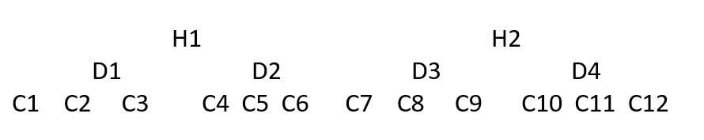

* 1. How are the variables nested? How does this nesting impact your analysis plan?

This model is fully nested, meaning that we cannot evaluate interactions between any of the three predictor variables. The three factors we can evaluate are: 1) Hospital, 2) Drug *within* Hospital, and 3) Condition *within* Drug *within* Hospital.

1. Read in the datafile “Nested_practice.csv”, check how the variables are read, and get variable descriptives

1. Use the aggregate function to calculate the mean values of Y by Hospital, Drug, and Condition.
   1. How much do the means of Y vary across the levels of each predictor?

The mean of Y is quite similar between the two hospitals and between the four drugs. The mean of Y varies a little more across the 12 treatment conditions, ranging from 7.70 to 9.89.

1. Use the following methods to analyze the effects of Hospital, Drug, and Condition on Y:
   1. Create an ANOVA Table listing the factors included in the design and the df for each

* 1. Conduct a one-way ANOVA for Hospital (ignoring Condition and Drug)

* 1. Conduct a one-way ANOVA for Drug (ignoring Condition)

* 1. Conduct a one-way ANOVA for Condition, and plug results into the ANOVA table

* 1. Conduct an ANOVA that evaluates the full nested model for the effect of hospital, drug, and condition on Y. Compare these results to the ANOVA table you got in part 4d.

* 1. Interpret the overall ANOVA table

None of the F statistics for the predictors are statistically significant at *p*<0.05. These results indicate that, when taking into account the nesting structure of the data, patient health (Y) did not significantly differ between the two hospitals, the four drugs, and the 12 treatment conditions.